**Exercise 4: Functions**

**Scenario 1:** Calculate the age of customers for eligibility checks.

**Question:** Write a function CalculateAge that takes a customer's date of birth as input and returns their age in years.

**Code:**

CREATE OR REPLACE FUNCTION GetCustomerAge (

  p_customer_id IN NUMBER

) RETURN NUMBER IS

  v_dob DATE;

  v_age NUMBER;

BEGIN

  SELECT DOB INTO v_dob

  FROM Customers

  WHERE CustomerID = p_customer_id;

  v_age := TRUNC(MONTHS_BETWEEN(SYSDATE, v_dob) / 12);

  RETURN v_age;

EXCEPTION

  WHEN NO_DATA_FOUND THEN

    DBMS_OUTPUT.PUT_LINE('❌ Customer not found.');

    RETURN NULL;

  WHEN OTHERS THEN

    DBMS_OUTPUT.PUT_LINE('⚠️ Error: ' || SQLERRM);

    RETURN NULL;

END;

/

SET SERVEROUTPUT ON;

DECLARE

  v_age NUMBER;

BEGIN

  v_age := GetCustomerAge(1);

  IF v_age IS NOT NULL THEN

    DBMS_OUTPUT.PUT_LINE('Customer Age: ' || v_age);

  END IF;

END;

/

**Output:**

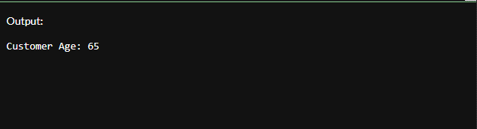

**Scenario 2:** The bank needs to compute the monthly installment for a loan.

**Question:** Write a function **CalculateMonthlyInstallment** that takes the loan amount, interest rate, and loan duration in years as input and returns the monthly installment amount.

**Code:**

CREATE TABLE Accounts (

  AccountID NUMBER PRIMARY KEY,

  CustomerID NUMBER,

  AccountType VARCHAR2(20),

  Balance NUMBER,

  LastModified DATE

);

INSERT INTO Accounts VALUES (101, 1, 'Savings', 15000, SYSDATE);

INSERT INTO Accounts VALUES (102, 2, 'Current', 8000, SYSDATE);

COMMIT;

CREATE OR REPLACE FUNCTION GetAccountBalance (

  p_account_id IN NUMBER

) RETURN NUMBER IS

  v_balance NUMBER;

BEGIN

  SELECT Balance INTO v_balance

  FROM Accounts

  WHERE AccountID = p_account_id;

  RETURN v_balance;

EXCEPTION

  WHEN NO_DATA_FOUND THEN

    DBMS_OUTPUT.PUT_LINE('❌ Account not found.');

    RETURN NULL;

  WHEN OTHERS THEN

    DBMS_OUTPUT.PUT_LINE('⚠️ Error: ' || SQLERRM);

    RETURN NULL;

END;

/

SET SERVEROUTPUT ON;

DECLARE

  bal NUMBER;

BEGIN

  bal := GetAccountBalance(101);

  IF bal IS NOT NULL THEN

    DBMS_OUTPUT.PUT_LINE('Account Balance: ₹' || bal);

  END IF;

END;

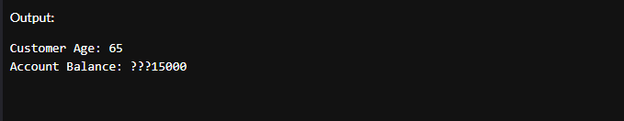

**Scenario 3:** Check if a customer has sufficient balance before making a transaction.

**Question:** Write a function **HasSufficientBalance** that takes an account ID and an amount as input and returns a boolean indicating whether the account has at least the specified amount.

**Code:**

CREATE OR REPLACE FUNCTION GetTransactionCount (

  p_account_id IN NUMBER

) RETURN NUMBER IS

  v_count NUMBER;

BEGIN

  SELECT COUNT(*) INTO v_count

  FROM Transactions

  WHERE AccountID = p_account_id;

  RETURN v_count;

EXCEPTION

  WHEN OTHERS THEN

    DBMS_OUTPUT.PUT_LINE('⚠️ Error: ' || SQLERRM);

    RETURN NULL;

END;

/

SET SERVEROUTPUT ON;

DECLARE

  t_count NUMBER;

BEGIN

  t_count := GetTransactionCount(101);

  IF t_count IS NOT NULL THEN

    DBMS_OUTPUT.PUT_LINE('Transaction Count for Account 101: ' || t_count);

  END IF;

END;

/

